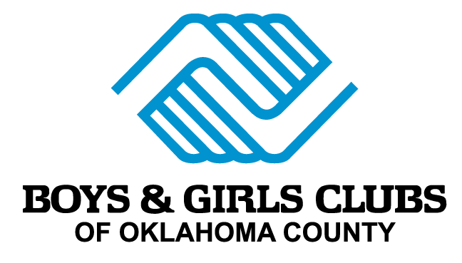

POSITION DESCRIPTION

TITLE: HR Director

DEPARTMENT: Human Resources

REPORTS TO: President & CEO

WORK SCHEDULE: Generally scheduled Monday through Friday from
8:00 a.m. – 5:00 p.m.

X Exempt Non-Exempt

PRIMARY FUNCTION:

The Director of Human Resources is responsible for managing and administering Boys & Girls Clubs of Oklahoma County’s and Boys & Girls Clubs of Metro Tulsa's human resources functions including, but not limited to, recruitment, payroll, supervising and providing consultation to management, onboarding, terminations, benefits, safety, employee relations, management and staff development, compliance with employment laws, overseeing performance reviews and more. This position will provide advice and counsel to management in the development and implementation of policies and practices that comply with all applicable regulations and are consistent with Boys & Girls Clubs’ mission and values.

KEY ROLES AND RESPONSIBILITIES: (not all inclusive)

- In collaboration with the President & CEO, COO, and appropriate board committees, establish and implement (as needed) policies and procedures for the effective management of Club human resources, ensuring compliance with federal, state and local regulations and community practices, as well as with Boys & Girls Clubs’ mission and values.

Administration of human resource programs including, but not limited to, compensation, benefits, and leave; disciplinary matters; disputes and investigations; performance and talent development & management; productivity, recognition, and morale; payroll accuracy; occupational health and safety; and training and development.

Manage administrative and operational systems for maintaining all employment and personnel records, ensuring compliance with legal requirements.

Collaborate with senior leadership to understand the organization’s goals and strategy related to staffing.

Provide organizational support to all Club sites including our Club on The Go Program and Administrative staff.

Oversee the recruitment function by ensuring the Recruiter has all of the tools and support necessary to do his/her job, as well as oversee the recruitment and selection process for leadership positions in Oklahoma City and in Tulsa.

Directly supervise Recruiter, Administrative Assistant, and other positions as may be needed.

Have the qualifications necessary to recommend recruitment sources and strategies, while ensuring the recruitment process and associated records are maintained in compliance with regulatory requirements.

Oversee and improve the onboarding process for all new employees, training management regularly on their roles in the process.

Support staff career development, identifying opportunities for training and skill building within budget limits.

Ensure a healthy and safe environment that complies with all OSHA and other regulatory requirements.

Provide information to staff to support management decision making about policy issues, employee relations, staff development needs, compensation and benefits practices and costs and recruitment practices.

Ensure a productive work environment that encourages positive, effective working relationships and open communications, and that is respectful of the gender and cultural diversity of Club staff, volunteers and members. Take prompt, appropriate action to respond to any conflicts that may arise between staff members.

In collaboration with the President & CEO and the COO, establish appropriate employee disciplinary and voluntary/involuntary termination policies and procedures, training management on their roles in these processes.

Annually review and, if necessary, revise all benefits agreements to provide the highest level of benefits at the lowest overall cost.

Ensure compliance with 401K, workers compensation, unemployment and other HR-related programs, and ensure claims are processed in a timely manner.

Support the payroll process, including compliance with federal, state, local, and organizational reporting requirements and tracking of PTO.

Control expenditures against budget, particularly in the areas of recruitment, compensation, benefits and staff development.

Conduct, research, and analyze organizational trends including review of reports and metrics from the organization’s human resource information system (HRIS) or talent management system.

Promote awareness of the Club and stimulate interest in employment opportunities with Boys & Girls Clubs of Oklahoma County and Boys & Girls Clubs of Metro Tulsa.
- Other duties as assigned.

SKILLS/KNOWLEDGE REQUIRED:

- Bachelor’s degree from an accredited college or university
- A minimum of 5 years of progressively responsible work experience in human resources management in non-profit organizations
- 3-5 years of direct supervisory experience
- Knowledge of regulatory requirements affecting human resources management
- Knowledge of best practices in human resources management
- Significant successful experience in professional development and conflict resolution
- Strong administrative, time management and organizational skills
- Must have a strong work ethic, positive attitude, high level of energy, and flexibility
- Excellent verbal and written communication skills, interpersonal and customer service skills
- Significant experience managing the payroll process for both part-time and full-time employees
- Experience designing and leading staff trainings, particularly in HR policies, OSHA, safety, and regulatory requirements
- Highly organized, able to manage multiple priorities and attentive to details
- Flexible, self-motivated, positive attitude, and works well in a team environment
- Scrupulous attention to detail and confidentiality
- Able to successfully perform multi-faceted projects in conjunction with day-to-day activities
- Computer literacy, including database management, payroll systems, and Microsoft Office
- Highly motivated and dedicated to the organization’s mission

SKILLS/KNOWLEDGE PREFERRED:

- Prior experience with/significant knowledge of Boys & Girls Clubs of America’s mission, values, policies, and expectations
- Experience facilitating organizational behavior and corporate culture changes
- Experience working with a large part-time hourly workforce
- PHR, SPHR, or SHRM-CP certification

GENERAL BOYS & GIRLS CLUBS OF OK COUNTY EXPECTATIONS:

- Safe Spaces—Every staff member shares the responsibility for ensuring BGCOKC is, and remains, an environment free of sexual, physical and/or emotional abuse.
- Modeling Healthy Behavior—teaching youth/teens the importance of living an active, healthy lifestyle is a BGCOKC priority. As a result, all staff are expected to model healthy behavior while working with our members including modeling healthy relationships with co-workers through teamwork.
- Inclusive Environment—BGCOKC values creating youth-friendly environments where youth/teens of all abilities can be successful and participate. BGOKC expects employees to embrace its focus on inclusion of all members, regardless of disability or developmental challenge.
- Continuous Learning—Building the capacity of staff is central to BGCOKC. The organization encourages and requires that all staff participate in annual professional development opportunities that continue to cultivate their skills in the youth development field.

PHYSICAL REQUIREMENTS/WORK ENVIRONMENT:

The job requires working, standing, bending, turning, reaching, talking, listening; works in a clean, well lighted, heated and ventilated building. On occasion, must work at other BGCOKC locations.

DISCLAIMER:

The information presented indicates the general nature and level of work expected of employees in this classification. It is not designed to contain, or to be interpreted as, a comprehensive inventory of all duties, responsibilities, qualifications and objectives required of employees assigned to this job.

